**How Do Life Settlements Fit Into an Institutional Portfolio: Alpha plus Correlation** *A comparison with main alternative asset classes*

*Index*

*1) Allocation Trends in Institutional Portfolio after Covid-19 disruption 2*

*a) Fixed Income 2*

*b) Alternative Investments 3*

*I) Real Estate, Private Equity and Hedge Funds: still good for diversification? 4*

*II) Rise of new asset classes 5*

*III) Life Insurance Securities 6*

*2) Conclusions 8*

*Appendix (Main Characteristics of Life Settlements) 9*

*Bibliography 10*

*1) Allocation Trends in Institutional Portfolio after Covid-19 disruption*  
  
Before trying to allocate Life Settlement within a specific category of institutional portfolios, it is important to define the expected investment trends over the course of the next few years.  
After decades of success, Covid-19 crisis showed that the historical 60/40 split between equities and bonds is no longer able to preserve the consistency of robust returns.  
Slow economic growth, low or negative interest rates, volatile markets and increasing geopolitical pressures put several issues on the classic 60/40 structure that well served them in the last 40 years.  
Both parts of the 60/40 split are going to underperform during this year: high valuation in equities (forward S&P 500 P/E at 21.7x compared to average historical of 15.4x) and high levels of risks associated with fixed income (low yields may lead to big prices changes and big potential losses in inflation rises) could force many investors to rethink their asset allocation soon.1  
  
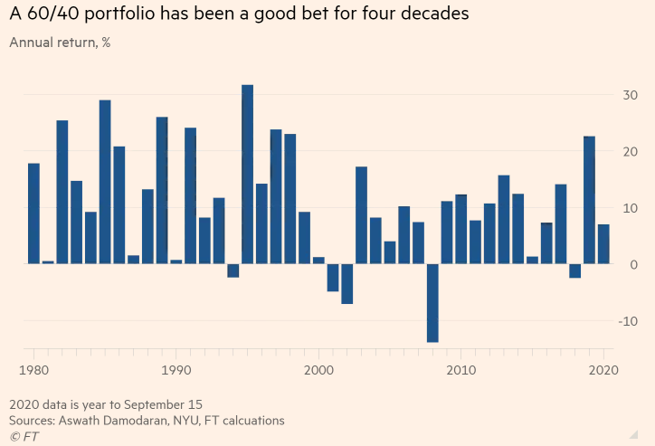

Most investors won’t reduce their equity allocation any time soon. It is therefore reasonable to assume that it is the fixed income that will see its portion within the portfolio being downsized.  
There are two main schools of thought that tend to dominate across the markets: to either find fixed income alternatives in order to replace traditional ones consistently or to increase overall portfolio allocation to alternatives as such.

*a) Fixed Income*  
Fixed income has always been an important part of the investor’s portfolios, particularly due to the bond’s historically low volatility and tendency to rise in value during times of market distress.COVID-19 crises and its huge effect on stock markets have caused main central banks to create new unprecedented levels of liquidity, dumping interest rates to zero and below. What is more worrisome is that US T-Bonds, traditionally considered to be the risk free asset, have also seen a rapid fall in prices during dual March 2020 selloff. Indeed the failure of Treasuries to serve as a hedge during times of major economic distress has pushed investors to further question the 60-40 portfolio model.  
Moreover, the fact that interest rates seem to remain stagnant in a medium term perspective, is making bonds particularly sensitive to inflation therefore increasing their risk.  
  
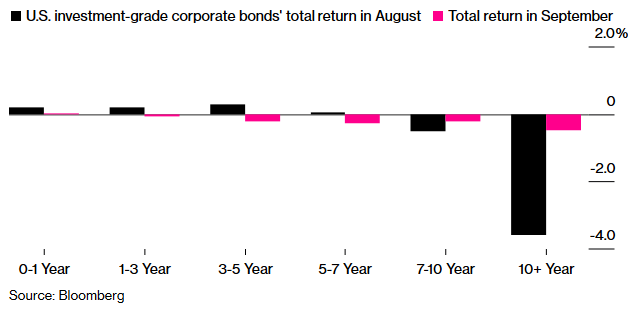

In this context, new categories of alternative investments (particularly liquid ones) have been designed as a potential alternative for fixed income due to the attractive yields and the diversification benefits that seem to match the historical characteristics of bonds.   
Indeed the mechanics of such alternative instruments, particularly cat bonds, life settlements, or annuities clearly reminds the one of the bond’s: there is initial purchase price which is based on DCF model, premiums to be paid during the course life of a contract and a set face value at the maturity.

However the risk - return profile, market size and liquidity remain to be very different from traditional fixed income instruments. The underlying variable is unique, which is exactly what turns those assets into a new hedging solution, sought after by pension funds, sovereigns funds and insurance companies.

*b) Alternative Investments*In the last few years, we have assisted to the constant increase of alternative investments as a % of total portfolio allocation. The ‘democratization of alternatives’ is a process that has started in 2009, whereby low interest rates as well as diversification needs have pushed many investors to look into this sub-set of assets.2  
COVID-19 and market plunge of March 2020 has accelerated this trend; most of allocators impacted by COVID-19 crisis, particularly large institutional ones, are more willing to shift from a classical 60/40 split to a more sophisticated and diversified pie.  
  
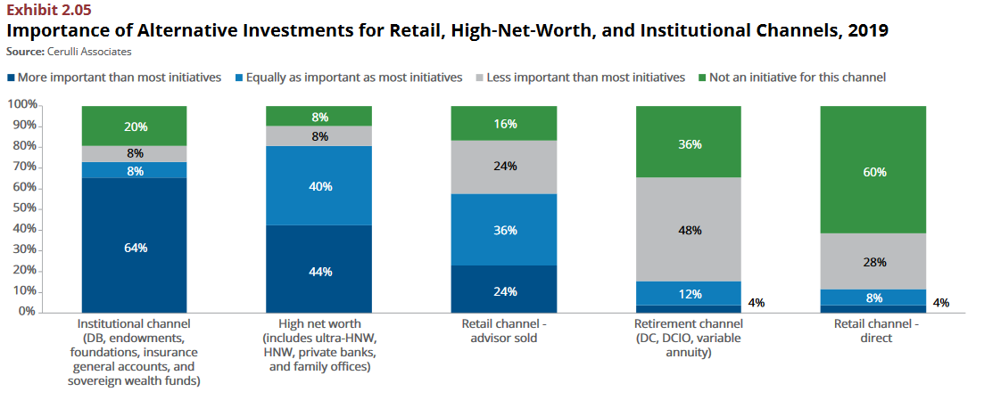  
  
  
They now tend to allocate an average of 26% of their assets to the alternatives, which represents YOY increase of 2% according to CoreData Research.  
About 40% of those polled by CoreData Research in June and July planned larger allocations to alternative strategies over the next three to five years, with 90% citing diversification as their main reason, according to the Cerulli report.3

The real question therefore is: which of the alternatives can provide truly de-correlated returns during the times of market distress?

*I) Real Estate, Private Equity and Hedge Funds: still good for diversification?*  
Real estate, private equity and hedge funds have traditionally been the 3 most established and commonly referred to types of alternatives. However their added value as portfolio diversifier has been somewhat diminished in scope of the recent COVID-19 crisis.

Recent data shows that HFRI Fund Weighted Composite Index already dumped by 1.2% in September, ending the 5 positive months performance since March, with fundamental equity, multi-strategy, quantitative and energy/materials strategies all registering losses.4  
  
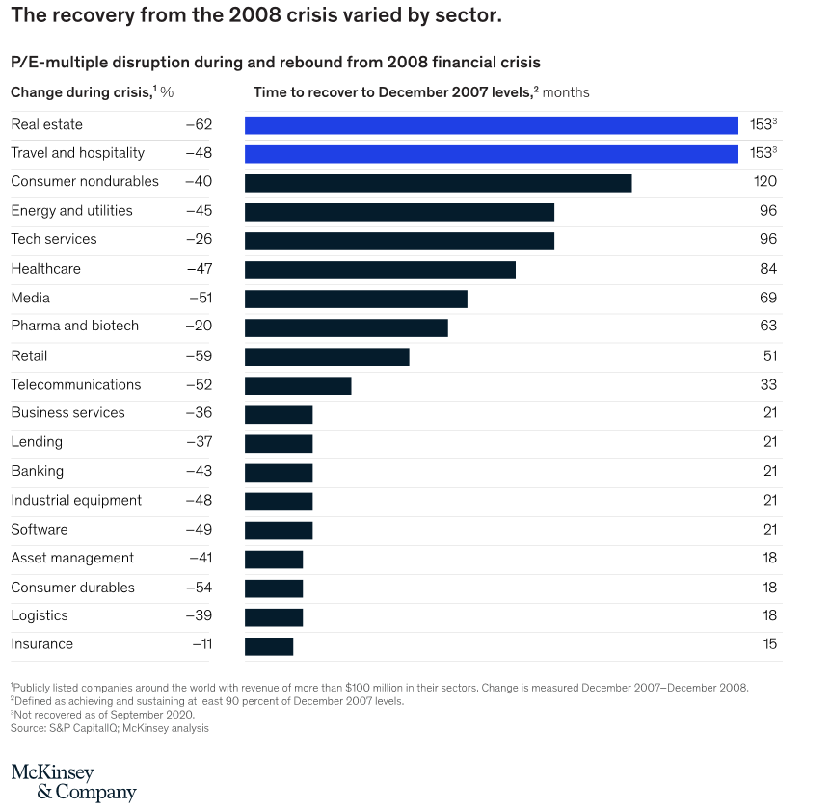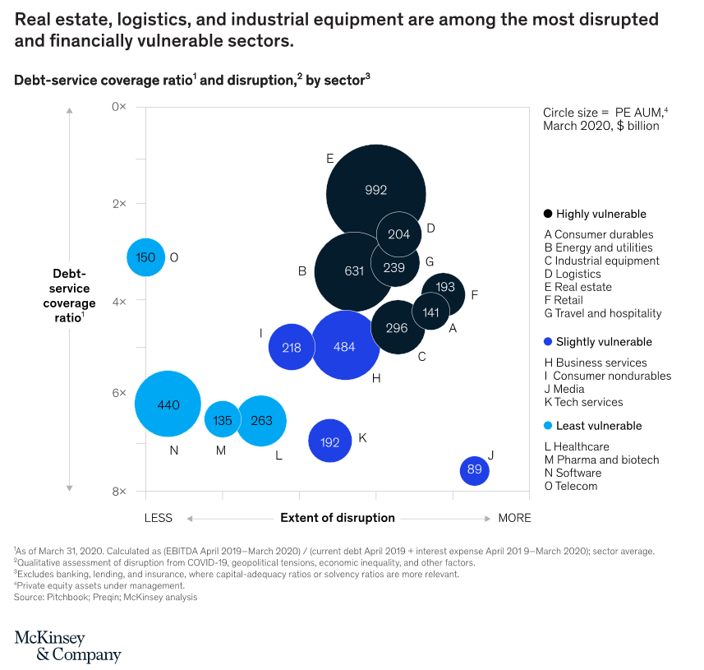  
  
Real estate sector, one of the most financially vulnerable sectors, have been heavily impacted by COVID-19. Disruption in manufacturing and transport which has limited construction and renovations pipeline, hampered expansion plans, reduced office-space demand due to increase in tele-working as well as high street retail footfall due to collapse in travel have all contributed to real estate volatility.

Private Equity as well had been largely impacted in March 2020, particularly in terms of volumes, while almost 50% of many companies within portfolios had no real business continuity plans in place before lockdown.5  
  
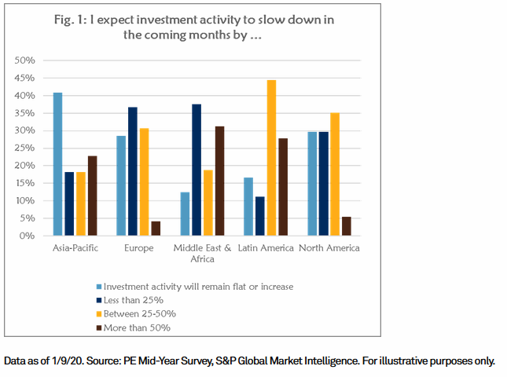 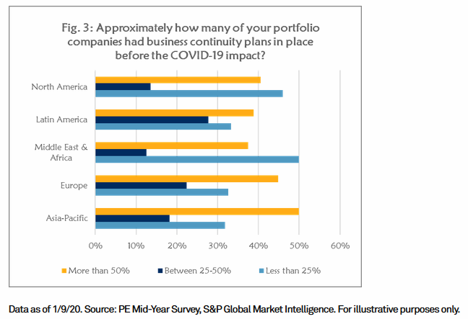  
  
European PE deal-making dropped to a five-year low in the first half of 2020, a 13% drop versus the same period of the previous year. The fall for US entries was even steeper, with a 26% year-over-year drop in deals announced.6

*II) Rise of new asset classes*  
Returns shown by major alternative asset classes during COVID-19 have therefore failed to demonstrate truly uncorrelated properties.   
  
Innovation has always been at the core of the alternative investment philosophy. It led to the discovery of a multiplicity of new asset classes but only few managed to capture the requirements of the institutional investors, most notably an Insurance-Linked Securities.   
  
ILS represent a broad spectre of financial instruments, all based on the same principle: assessment of the insurance risk, covering for the specific event such as but not limited to catastrophe or person’s death. Their performance is therefore contingent on the occurrence of the specific insurance event.

There are 2 main categories: Non-Life Insurance Linked Securities (i.e. Catastrophe Bonds et al.) and Life Insurance Linked Securities (i.e. Life Settlements et al.).  
Both main types fall below the ESG-oriented investments (Environmental Social and Corporate Governance), particularly Catastrophe Bonds for what it concerns the E -Environmental - part (designed to provide additional sources of capital to help the broader societal goal of helping countries and communities recover from disastrous events) and Life Settlements for the S – Social - part (providing much needed liquidity to seniors in possession of unwanted or unneeded life insurance policy).7

Let’s take a deeper look at the latter one.

*III) Life Insurance Securities*  
Life settlements is the subcategory of ILS for which the underlying value is contingent on the so called life expectancy or longevity risk. Next to IT and healthcare, this is one of the few asset classes positively impacted by the COVID-19 crisis, due to its underlying asset.8

Several factors led to the inception of Life Settlements.

First of all, the huge volume of active life insurance in US.

Secondly, the regulatory framework which has established life insurance policy to be a private property.

Third, the aging population and skyrocketing policy lapse rates which caused many US seniors, to look for an exit strategy for an unwanted or unneeded life insurance policy.

In favour of covering more immediate healthcare or pension expenses. Further 2017 amendments to the federal estate tax exemption have made more policies obsolete.   
LS supply curve is therefore poised to shift to the right within next years and while the attractive yields have already attracted larger private equity houses to the industry, thus moving the demand curve up.   
From an institutional perspective, what truly differentiates life settlements from previously mentioned alternatives is the robustness of the valuation: despite the asset class being relatively young and innovative, the fundamentals have been built on over a century old life insurance industry, with valuation models in place that have been largely utilized by large pension funds and insurance carriers for hundreds of years.  
  
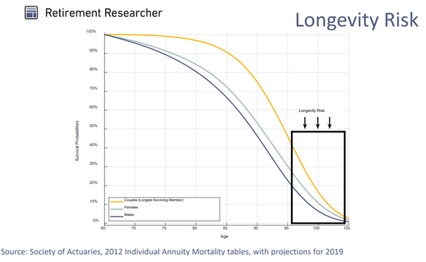  
  
Longevity risk is historically one of the first risks ever followed and quantified by humankind.  
Increasing speed and quality of data collection efforts, the improved actuarial analysis of the last years (stochastic models, Monte Carlo simulations, stress tests & scenario analysis) made it is easier to understand and measure life settlements when compared to other new asset classes. Ability to measure and stress test what is effectively the only truly isolated mortality variable is key for the asset class. A robust and reliable valuation methodology is definitely a substantial advantage to be considered by an institutional investor who is looking to diversify its portfolio.

**Below can be further demonstrated with the low to negative correlation LS index tends to display with other major asset classes as well as its outperformance over the past 7 years**

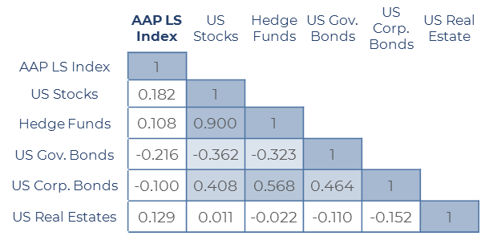

Source: Bloomberg, AAP Life Settlements Index

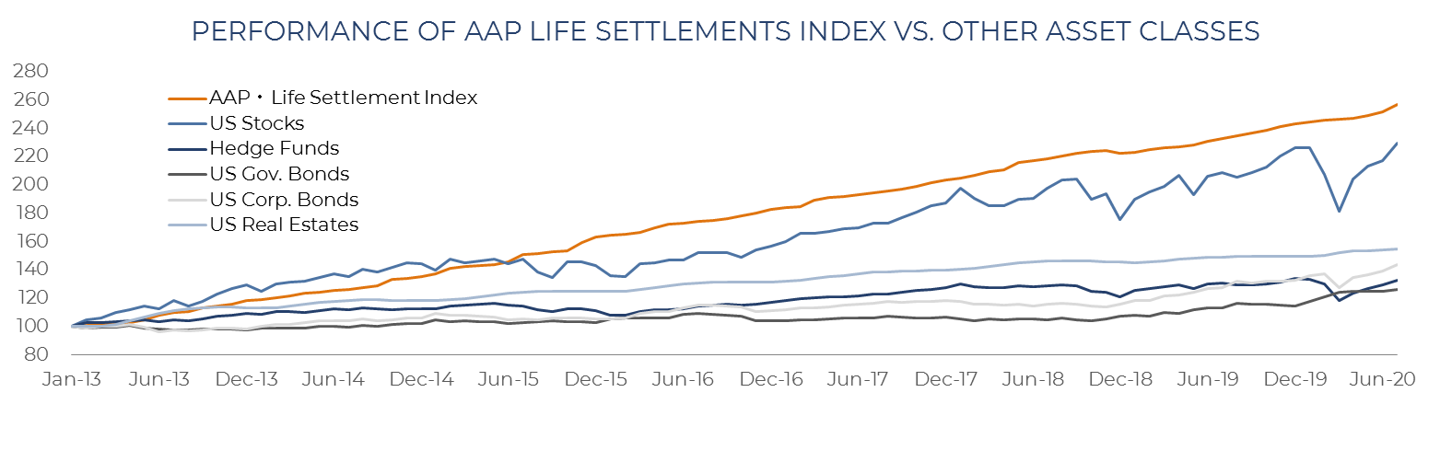Source: Bloomberg, AAP Life Settlements Index

Other benefits include stability, caused by high entry barriers, market neutrality and high credit quality, especially where LS serve as a substitute to fixed income alternatives.

**Sum-up**  


*2) Conclusions*

The disruptive effects of Covid-19 posed serious questions regarding the validity of the traditional 60/40 allocation in being able to hedge your portfolio  
Most of investors won’t receive the same expected return as the one we have experienced over the course of the last 20 years, which is why today is the perfect time to re-consider the importance of alternatives in your strategy. Their share is expected to increase up to 25% of the average institutional portfolio, representing a huge increase since 2008 financial crisis.  
Covid-19 black swan scenario showed that most of ‘traditional’ alternative investments, such as real estate, private equity and hedge funds, have been strongly impacted by this adverse scenario, emphasizing lack of diversification benefit they are expected to provide. New alternative asset classes have emerged in the last years including litigation finance and insurance-linked securities.  
All tend to demonstrate robust returns, solid opportunities in the markets and truly de-correlated nature.  
The main difference is therefore in the valuation: Cat bonds valuations (often not easy to understand for most subjects of financial sector)have badly impacted investors during 2017 and 2018, while longevity risk offers a much more sophisticated and robust approach, developed by actuarial analysis and well used through years by insurance carriers and pension funds.  
While Life Settlements has essentially been as a "nice to have” asset from the returns perspective, majority of investors nowadays are looking in space as a “need to have” investment because due to diversification benefit.  
  
With a continuous YoY increase of Life Settlement market volume, increased interest on behalf of large private equity houses, higher standardization and efficiency it is unlikely that Life Settlements will remain an undiscovered niche for much longer, which makes an even bigger case for those ultra-specialized small to mid-size managers who often win when compared to multibillion “one stop shops” investing across multiple asset classes. Unique operational knowledge developed throughout years, vast sourcing network, often lower fee structure and most importantly ability to exploit very niche trading opportunities that just don’t have capacity for absorb billions of dry powder available to larger players remain key. This is what a specialized life settlements structure can definitely provide to many of the institutional investors.

*Appendix (Main Characteristics of Life Settlements)*  
  
  
   
* Open-ended structures only

*Bibliography*

1. <https://www.ft.com/content/fdb793a4-712e-477f-9a81-7f67aefda21a>
2. <https://www.wealthadviser.co/2020/06/15/286511/hnw-investors-gearing-alternative-investment-opportunities>
3. <https://www.institutionalinvestor.com/article/b1np4x2kqcyzst/What-s-Driving-Multi-Asset-Funds-Into-Alternatives>
4. <https://www.hedgeweek.com/2020/10/08/290657/hedge-funds-stumble-september-stormy-markets-bring-five-month-surge-end>
5. <https://www.mckinsey.com/industries/private-equity-and-principal-investors/our-insights/a-rolling-disruption-covid-19s-implications-for-private-equity-and-portfolio-companies>
6. <https://www.spglobal.com/marketintelligence/en/news-insights/research/the-impact-of-the-covid19-pandemic-on-the-private-equity-market>
7. <https://www.invesco.com/emea/en/invesco-insights/insights/cat-bonds-and-ils-are-a-fundamentally-esg-oriented-investments.html>
8. <https://www.businessinsurance.com/article/20200929/NEWS06/912336750/Insurance-linked-securities-rebound-from-pandemic-disruption>

*Additional Lectures:*

* <https://thehedgefundjournal.com/beyond-60-40/>
* <https://www.nasdaq.com/articles/the-rise-of-alternative-investments%3A-how-central-bank-stimulus-has-forced-a-rethink-2020>
* <https://pitchbook.com/news/articles/qa-why-life-insurance-and-lawsuits-might-be-the-next-big-things-for-pe>
* <https://www.streetinsider.com/Business+Wire/Alternative+Investment+Professionals+Predict+That+Full+Deal+Activity+Will+Return+in+2021/17467178.html>
* <https://litigationfinancejournal.com/value-in-litigation-implications-for-litigation-finance/>  
    
  <https://www.investopedia.com/terms/c/catastrophebond.asp>
* <https://www.bloomberg.com/news/articles/2020-10-13/bond-markets-suggest-don-t-write-off-inflation-risks-just-yet>  
    
  <https://www.artemis.bm/news/ils-asset-valuation-an-art-and-a-science-horseshoes-jb-crozet/>  
    
  <https://www.investopedia.com/terms/c/catastrophebond.asp>  
    
  <https://www.partnerre.com/assets/uploads/docs/The-Drivers-of-Catastrophe-Bond-Pricing.pdf>
* The Cerulli Report – US Alternative Investments 2019, Democratization of Alternatives
* Aon PLC’s mid-year ILS report – September 2020